Angela K. Gosman
Senior Vice President and Chief Human Resources Officer, PPL Corporation

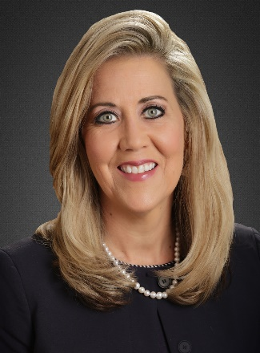
Angela K. Gosman is senior vice president and chief human resources officer for PPL Corporation.
She provides enterprise-wide oversight and direction for PPL’s human resources across Kentucky, Pennsylvania, Rhode Island and Virginia. She oversees compensation; benefits administration; diversity, equity and inclusion; health services; talent acquisition; organizational development; employee relations, labor relations; HR system operations; HR data analytics and workforce planning.
Prior to this role, Gosman had served as vice president-Human Resources for PPL Electric Utilities from May 2020 until July 2021.
Prior to that, Gosman served as the director of Human Resources at PPL subsidiary Louisville Gas and Electric and Kentucky Utilities, a company she joined in 1986.
In a career spanning more than 30 years, Gosman has served in a variety of human resources leadership roles. In her previous role in Kentucky, Gosman was responsible for providing leadership in all aspects of human resources strategy and management. She successfully incorporated data analytics in human resources to identify risks and opportunities. She is a proven collaborative professional with well-rounded experience in the utility industry and successful stints in Corporate, Generation, Gas, Distribution, Energy Marketing and Transmission at LG&E and KU. Over the course of her tenure, she has been involved in countless efforts of great significance, including system upgrades, union negotiations and expansion of organizational development programs.
Gosman received her Bachelor of Science degree in management from Indiana Wesleyan University. Gosman was raised in Bedford, Kentucky and lived in Crestwood, Kentucky prior to relocating to Pennsylvania. Gosman served as the first vice chair at Maryhurst, a youth social services organization in Louisville. She strongly believes in their mission to provide healing for the community’s most traumatized children. She also served as chair on Maryhurst’s HR Executive Committee. Gosman is also an advocate for women’s leadership development and has served on the board of directors at Women Influencing Louisville, an organization committed to providing leadership opportunities to women through professional development, mentoring and networking.
She currently resides in Breinigsville, Pennsylvania with her husband Glenn and their dog Darby. They are blessed with two children, Kaylenn and Brody who are both married and live in the Louisville area. Angie and Glenn love to travel and spend time outdoors, hiking, biking and kayaking.

